**LAB CLASS -1**

**Class topic :**

* 1.heading tag
* 2.paragraph tag
* 3.Anchor tag
* 4.image tag

HTML Code (index.html):

<!DOCTYPE html>

<html lang="en">

<head>

<meta charset="UTF-8">

<meta name="viewport" content="width=device-width, initial-scale=1.0">

<title>Document</title>

</head>

<body>

<h1>My first heading</h1>

<h2>My first heading</h2>

<h3>My first heading</h3>

<h4>My first heading</h4>

<h5>My first heading</h5>

<h5>My first heading</h5>

<h6>My first heading</h6>

<p>Lorem, ipsum dolor sit amet consectetur adipisicing elit. Hic, amet!</p>

<a href="https://www.youtube.com/">Youtube</a><br>

<img src="image/image5.jpg" alt="logo" height="320px" width="400px">

</body>

</html>

Output :

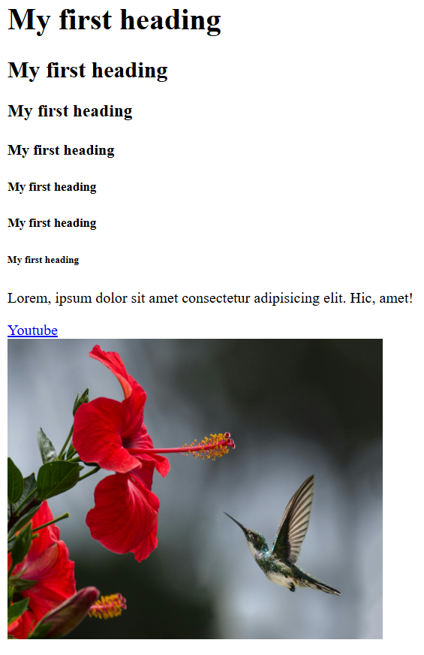

**LAB CLASS -2**

**Class topic :**

HTML:

* 1.inline,internal,external styling
* 2.abbreviation , mailto tag
* 3.image map , Responsive Image

CSS:

          background-color,font-family,color (including rgba())

          ,text-align,width, height,background image add,selector

HTML Code (index.html);

<!DOCTYPE html>

<html lang="en">

<head>

    <meta charset="UTF-8">

    <meta name="viewport" content="width=device-width, initial-scale=1.0">

    <title>Document</title>

    <link rel="stylesheet" href="css/index.css">

    <style>

        p{

    background-color: bisque;

    font-family: 'Times New Roman', Times, serif;

    color: brown;

    text-align: justify;

    }

    </style>

</head>

<body>

    <abbr style="color: rgba(0, 54, 52, 0.59)"

      title="The World Health Organization">WHO</abbr>

    <p>Lorem ipsum dolor sit amet consectetur adipisicing elit.

        Deserunt, earum dicta cum aliquid ex quam enim! Exercitationem

        nemo praesentium sint.</p>

    <a href="mailto:shahriarshepo@gmail.com">Send email</a><br>

    <img src="image/image1.jpg" alt="Scenery"

        usemap= "#scene" width="500px" height="500px">

        <map name="scene">

            <area shape="rect" coords="0, 0, 300,300" href="image/image2.jpg" alt=""></map>

        <!-- <picture>

            <source media="(min-width: 850px)" srcset="image/pic1.jpg">

            <source media="(min-width: 665px)" srcset="image/pic2.jpg">

            <img src="image/pic3.jpg" style="width:auto;">

          </picture> -->

</body>

</html>

img{

    width: 500px;

    height: 500px;

}

body{

    background-image: url('../image/image2.jpg');

    background-repeat: no-repeat;

    background-attachment: fixed;

    background-size: cover;

}

    p{

    background-color: brown;

    font-family: 'Times New Roman', Times, serif;

    color: bisque;

    text-align: justify;

    }

 a:link {

        color: green;

        background-color: transparent;

        text-decoration: none;

      }

CSS Code (index.css:

      a:visited {

        color: pink;

        background-color: transparent;

        text-decoration: none;

      }

      a:hover {

        color: red;

        background-color: transparent;

        text-decoration: underline;

      }

      a:active {

        color: yellow;

        background-color: transparent;

        text-decoration: underline;

      }

      img{

        float: right;

    }

Output:

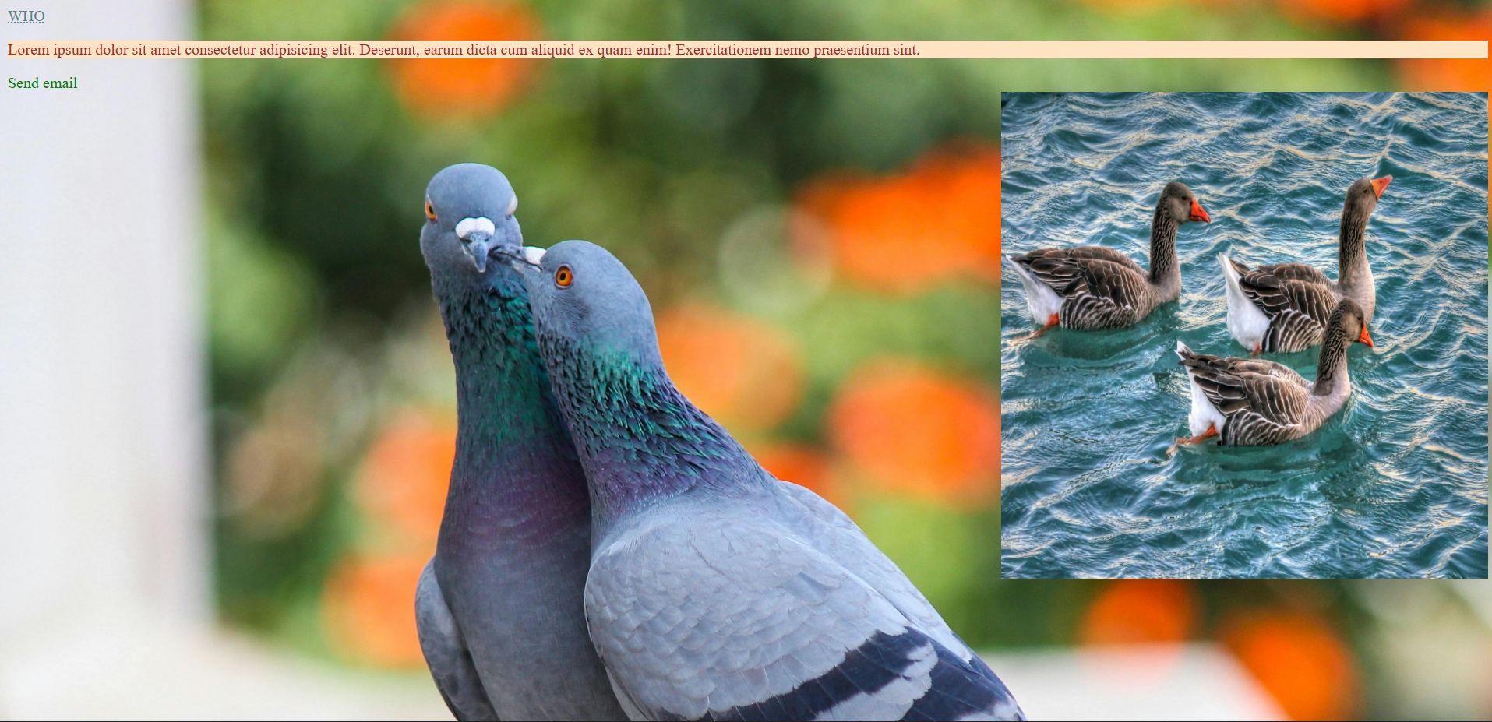

**LAB CLASS -3**

**Class topic:**

HTML:

* 1.Meta tags
* 2.Tables
* 3.Divs,Span
* 4.Iframe,Forms,list

HTML Code (index.html) :

<!DOCTYPE html>

<html lang="en">

  <head>

    <meta charset="UTF-8" />

    <meta name="viewport" content="width=device-width, initial-scale=1.0" />

    <title>Student Info</title>

    <link rel="stylesheet" href="css/index.css" />

    <style>

      h1 {

        color: rgb(4, 4, 5);

        text-align: center;

      }

    </style>

  </head>

  <body>

    <h1>Student Records</h1>

    <table>

      <caption> Student Details</caption>

        <tr><th>Name</th><th>Subject</th><th>Grade</th></tr>

      <tr>  <td > Nobin Chandra</td><td>IIT</td><td>A</td> </tr>

      <tr><td>Raju</td> <td>Math</td><td>B</td></tr>

      <tr><td colspan="3">Total student: </td></tr>

  </table>

    <div class="test">

      This section explains about **HTML basics**. HTML stands for HyperText

      Markup Language and is used to structure a web page with tags.

    </div>

    <div class="test">

      CSS is used for styling web pages. It controls layout, colors, spacing,

      and makes pages responsive across different devices.

    </div>

    <div class="test">JavaScript adds functionality to a website. It can handle events,

      validate forms, and make interactive web applications.

      Example: <span id="myspan">alert()</span> shows a message box.</div>

    <iframe class="center" src="html/second.html" width="500px" height="300px"> </iframe>

    <form action="second.html" class="form-box">

      <label for="fname">First Name</label>

      <input type="text" name="fname" id="fname" />

      <label for="lname">Last Name</label>

      <input type="text" name="lname" id="lname" />

      <input type="submit" />

    </form>

  </body>

</html>

CSS Code(index.css):

th {

  background-color: #f4f9fa;

  color: #03045e;

}

tr:nth-child(even) {

  background-color: #caf0f8;

}

.test {

background-color: #fefae0;

  border-radius: 15px;

  color: #333;

  width: 280px;

  height: 250px;

  float: left;

  padding: 20px;

  border: 2px solid #9a8c98;

  margin: 15px;

  box-shadow: 2px 4px 10px rgba(0,0,0,0.1);

}

#myspan {

  color: #d00000;  font-weight: bold;

}

.center {

  display: block;

  margin-left: auto;

  margin-right: auto;

  border: 2px solid #0077b6;

  border-radius: 10px;

  margin-top: 30px;

}

body {

  min-height: 100vh;

  background: linear-gradient(135deg, #f0f9ff, #cbebff);

  margin: 0;

  font-family: Arial, sans-serif;

  padding: 20px;

}

table {

  background-color: white;

  border: 2px solid #63b87c;

  width: 60%;

  height: auto;

  margin-left: auto;

  margin-right: auto;

  margin-bottom: 40px;

  padding: 10px;

  border-collapse: collapse;

  box-shadow: 0 4px 10px rgba(0, 0, 0, 0.1);}

caption {

  font-size: 20px;

  font-weight: bold;

margin-bottom: 10px;

  color: #023e8a; }

tr, th, td {

  border: 1px solid #0077b6;

  padding: 10px;

  text-align: center; }

.form-box {

  background: #f1f1f1;

  padding: 20px;

  width: 400px;

  margin: 40px auto;

  border-radius: 12px;

  border: 2px solid #0077b6;

  box-shadow: 0 4px 10px rgba(0,0,0,0.1);

}

.form-box label {

  display: block;

  margin-top: 10px;

  font-weight: bold;

}

.form-box input[type="text"] {

  width: 95%;

  padding: 8px;

  margin-top: 5px;

  border-radius: 6px;

  border: 1px solid #888;

}

.form-box input[type="submit"] {

  margin-top: 15px;

  padding: 10px;

  background-color: #0077b6;

  color: white;

  border: none;

  border-radius: 6px;

  cursor: pointer;

}

.form-box input[type="submit"]:hover {

  background-color: #023e8a;

}

**Output:**

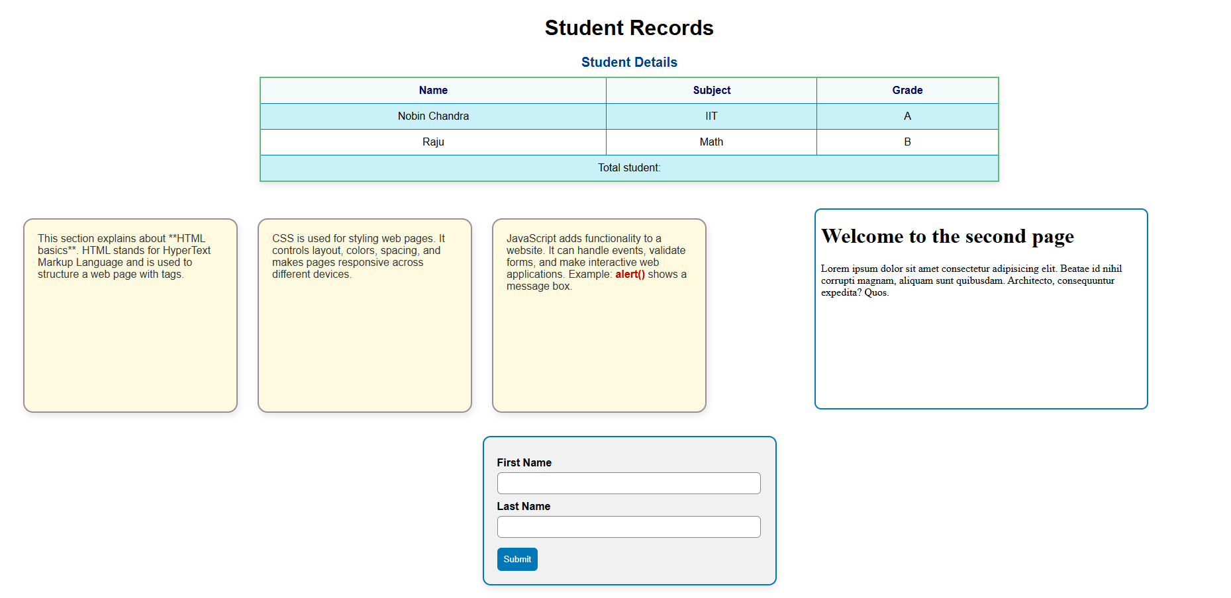

**LAB CLASS -4**

**\*\***index.html and index.css file contain same code which is present in Lab Class-3. Just change happened in second page..

HTML Code(second.html):

<!DOCTYPE html>

<html lang="en">

<head>

  <meta charset="UTF-8">

  <meta name="viewport" content="width=device-width, initial-scale=1.0">

  <title>Mini Webpage</title>

  <style>

    body {font-family: Arial, sans-serif; margin:0; text-align:center; background:#f0f8ff;}

    header {background:#0077b6; color:white; padding:15px;}

    nav a {color:white; margin:0 10px; text-decoration:none;}

    .hero {padding:50px 20px; background:linear-gradient(135deg,#4e885a,#6f7f64); color:#f0f2f5;}

    .hero button {padding:10px 20px; border:none; background:#0077b6; color:white; border-radius:5px; cursor:pointer;}

    .cards {display:flex; justify-content:center; gap:15px; padding:30px; flex-wrap:wrap;}

    .card {background:white; padding:15px; width:200px; border-radius:8px; box-shadow:0 2px 6px rgba(0,0,0,0.2);}

    footer {background:#282242; color:white; padding:10px;}

  </style>

</head>

<body>

  <header>

    <h2>Welcome to the second page</h2><hr>

    <nav>

      <a href="#">Home</a><a href="#">About</a><a href="#">Services</a><a href="#">Contact</a>

    </nav>

  </header>

<section class="hero">

    <h1>Welcome!</h1>

    <p>Simple webpage with HTML & CSS</p>

    <button>Get Started</button>

  </section>

  <footer>

    <p>© 2025 powered by nobin</p>

  </footer>

</body>

</html>

Output: 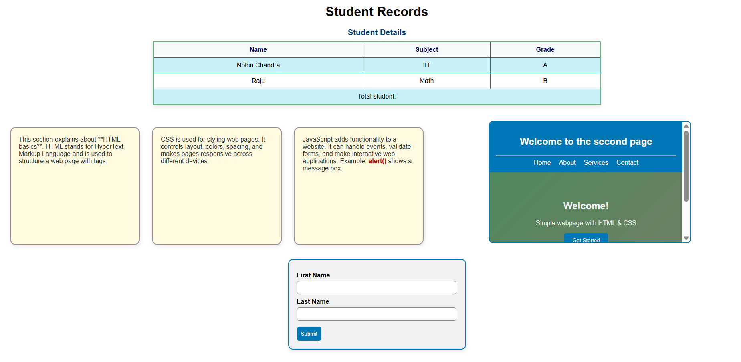

**LAB CLASS -5**

**Class topic:**

* Bootstrap usage and div alignment in row-wise in a parent dive ex.( start, center, end)

HTML Code(index.html):

<!DOCTYPE html>

<html lang="en">

<head>

  <meta charset="UTF-8" />

  <meta name="viewport" content="width=device-width, initial-scale=1.0" />

  <title>Lab Class 5</title>

  <link rel="stylesheet" href="css/index.css" />

  <link rel="stylesheet" href="https://cdn.jsdelivr.net/npm/bootstrap@4.1.3/dist/css/bootstrap.min.css">

</head>

<body>

  <div class="container">

    <div class="container-lg text-center zindex-dropdown">HI I am Nobin.

    </div>

    <div class="container">

        <div class="row" style="height: 150px; background-color: #eee;">

          <div class="col align-self-start col-start"> One of three columns  </div>

          <div class="col align-self-center col-center"> One of three columns</div>

          <div class="col align-self-end col-end">One of three columns</div>

        </div>

    </div>

    </div>

    <hr />

    <figure class="quote">

     <blockquote><p>A well-known quote, contained in a blockquote element.</p></blockquote>

      <figcaption> Someone famous in <cite>Source Title</cite>      </figcaption>

    </figure>

    <div class="image-container">

      <figure><img src="image/image3.jpg" alt="Rainy Day" />

        <figcaption>Birds</figcaption></figure>

    </div>

  </div>

</body>

hr {

  border: 1px solid #212529;

  margin-bottom: 30px;

}

.quote blockquote {

  font-size: 1.2rem;

  margin: 0 0 10px 0;

  padding-left: 15px;

  border-left: 4px solid #0dcaf0;

}

.quote figcaption {

  font-size: 1rem;

  color: #948c8c;

}

.image-container {

  text-align: center;

}

.image-container img {

  width: 400px;

  border-radius: 12px;

}

.image-container figcaption {

  margin-top: 10px;

  font-style: italic;

  color: #495057;

}

</html>

CSS Code(index.css):

body {

  font-family: Arial, sans-serif;

  margin: 0;

  background-color: #f8f9fa;

}

.container {

  max-width: 1200px;

  margin: 30px auto;

  padding: 40px;

  background-color: #e9ecef; }

.title {

  text-align: center;

  color: #0dcaf0;

  font-size: 3rem;

  margin-bottom: 30px; }

.col {

  flex: 1;

  padding: 20px;

  border-radius: 8px; }

.col-start { background-color: #a576f1; color: #010f08; }

.col-center { background-color: #e7ecb1; color: #000000; }

.col-end { background-color: #d38fb9; color: #000000; }

Output :

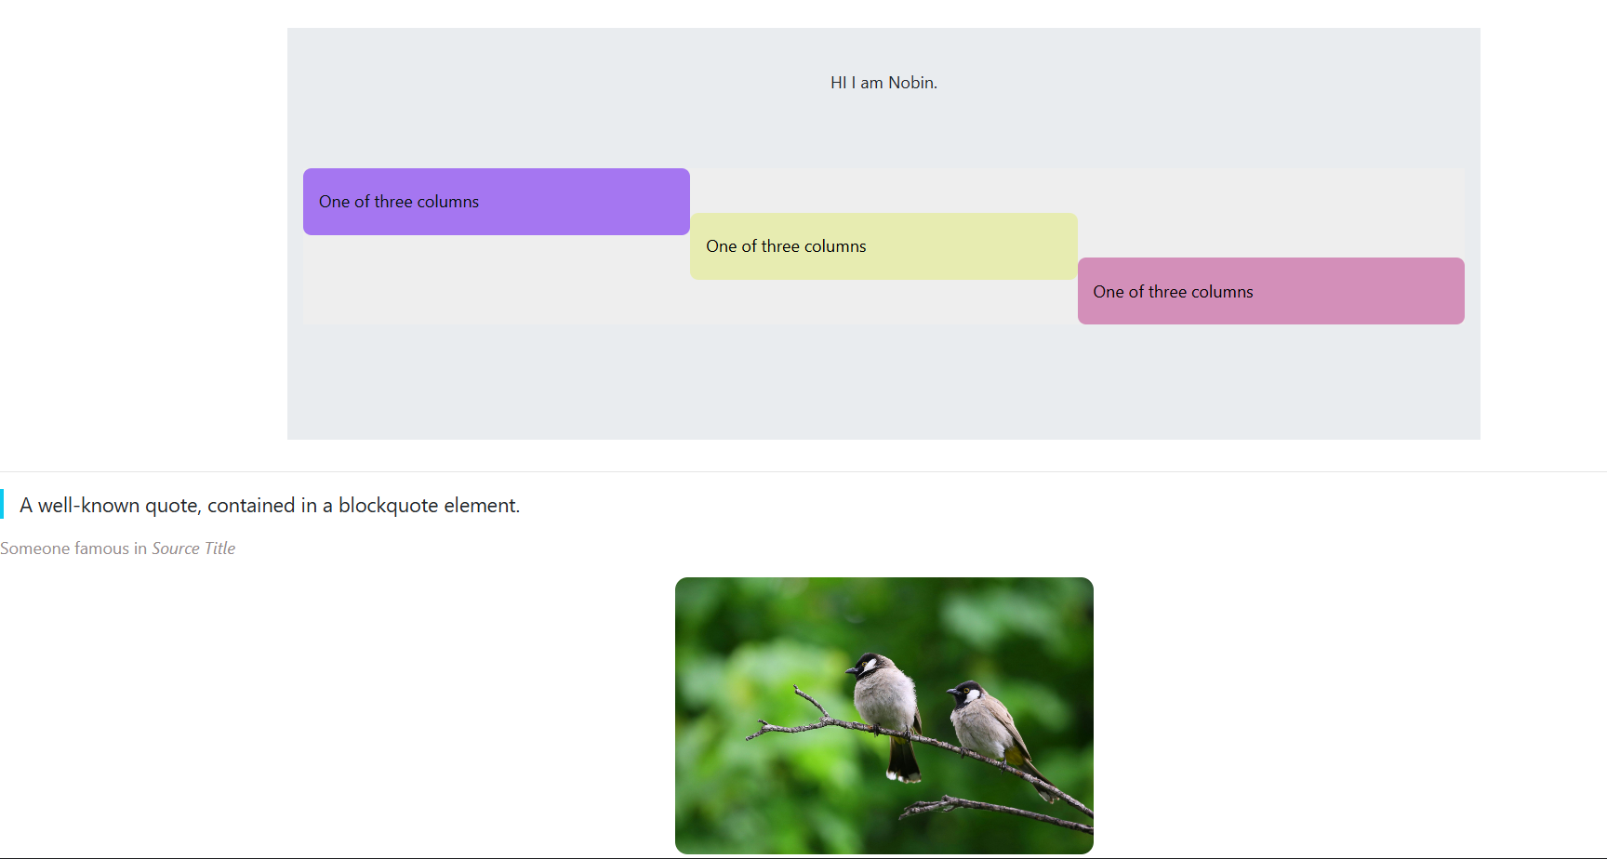

**LAB CLASS -6**

**Class topics:**

* Navbar design using bootstrap
* Accordion property of bootstrap
* Card design and Carousel property of bootstrap to make slider
* Alert slide through button

HTML Code(index.html):

<!DOCTYPE html>

<html lang="en">

<head>

    <meta charset="UTF-8">

    <meta name="viewport" content="width=device-width, initial-scale=1.0">

    <title>Document</title>

    <style>  #carouselExampleCaptions{ width: 600px;}     </style><script src="https://cdn.jsdelivr.net/npm/bootstrap@5.3.5/dist/js/bootstrap.bundle.min.js"></script>

    <link rel="stylesheet" href="https://cdn.jsdelivr.net/npm/bootstrap@5.3.5/dist/css/bootstrap.min.css">

</head>

<body>

    <nav class="navbar navbar-expand-lg navbar-light bg-light">

        <div class="container-fluid"><a class="navbar-brand fs-4" href="#">MySite</a>

          <button class="navbar-toggler" type="button" data-bs-toggle="collapse" data-bs-target="#navbarButtons" aria-controls="navbarButtons" aria-expanded="false" aria-label="Toggle navigation">

            <span class="navbar-toggler-icon"></span></button>

          <div class="collapse navbar-collapse" id="navbarButtons">

            <div class="ms-auto d-flex flex-wrap gap-3">

              <button class="btn btn-outline-primary nav-button" onclick="location.href='home.html'">Home</button>

              <button class="btn btn-outline-secondary nav-button" onclick="location.href='about.html'">About</button>

              <button class="btn btn-outline-success nav-button" onclick="location.href='services.html'">Services</button>

              <button class="btn btn-outline-danger nav-button" onclick="location.href='contact.html'">Contact</button>   </div></div>   </div></nav>

    <div class="container">

        <div class="accordion" id="accordionPanelsStayOpenExample">

            <div class="accordion-item">

              <h2 class="accordion-header">

                <button class="accordion-button" type="button" data-bs-toggle="collapse" data-bs-target="#panelsStayOpen-collapseOne" aria-expanded="true" aria-controls="panelsStayOpen-collapseOne"             Dhaka</button></h2>

              <div id="panelsStayOpen-collapseOne" class="accordion-collapse collapse show">

                <div class="accordion-body">

                  <strong>This is the first city of Bangladesh of all genjam.Such a boring city.</strong> It is shown by default, until the collapse plugin adds the appropriate classes that we use to style each element.<code>.accordion-body</code>

                </div></div></div>

            <div class="accordion-item"><h2 class="accordion-header">

                <button class="accordion-button collapsed" type="button" data-bs-toggle="collapse" data-bs-target="#panelsStayOpen-collapseTwo" aria-expanded="false" aria-controls="panelsStayOpen-collapseTwo">       Rangpur</button></h2>

              <div id="panelsStayOpen-collapseTwo" class="accordion-collapse collapse">

                <div class="accordion-body">

                  <strong>Actually it is not a city.</strong></div></div></div>

            <div class="accordion-item"><h2 class="accordion-header"><div class="card" style="width: 600px;">

            <img src="images/go.png" height="200px"  class="card-img-top" alt="...">

            <div class="card-body">

              <h5 class="card-title"><b>Picture Added</b></h5>

              <p class="card-text">He isn’t blind — he just closes his eyes to truth and calls it wisdom.</p></div>

            <ul class="list-group list-group-flush">

              <li class="list-group-item">Nice</li>

              <li class="list-group-item">Another list</li></ul>

<div class="card-body">

              <a href="#" class="card-link">Card link</a>

              <a href="#" class="card-link">Another link</a></div></div>

          <div id="carouselExampleCaptions" class="carousel slide">

            <div class="carousel-indicators">

              <button type="button" data-bs-target="#carouselExampleCaptions" data-bs-slide-to="0" class="active" aria-current="true" aria-label="Slide 1"></button>

              <button type="button" data-bs-target="#carouselExampleCaptions" data-bs-slide-to="1" aria-label="Slide 2"></button>

              <button type="button" data-bs-target="#carouselExampleCaptions" data-bs-slide-to="2" aria-label="Slide 3"></button></div>

            <div class="carousel-inner" style="width: 600px;"> <div class="carousel-item active">

                <img src="images/man-gobbling-down-pasta.jpg" class="d-block w-100" alt="...">

                <div class="carousel-caption d-none d-md-block"><h5>First slide label</h5>

                  <p>Some representative placeholder content for the first slide.</p>        </div> </div>

              <div class="carousel-item">

                <img src="images/topic-sleep-hero.jpg" class="d-block w-100" alt="...">

                <div class="carousel-caption d-none d-md-block">

                  <h5>Second slide label</h5>

                  <p>Some representative placeholder content for the second slide.</p></div></div>

              <div class="carousel-item"><img src="images/man-gobbling-down-pasta.jpg" width=

"600px" class="d-block w-100" alt="...">

                <div class="carousel-caption d-none d-md-block"><h5>Third slide label</h5>

                  <p>Some representative placeholder content for the third slide.</p></div></div></div>

            <button class="carousel-control-prev" type="button" data-bs-target="#carouselExampleCaptions" data-bs-slide="prev">

              <span class="carousel-control-prev-icon" aria-hidden="true"></span>

              <span class="visually-hidden">Previous</span></button>

            <button class="carousel-control-next" type="button" data-bs-target="#carouselExampleCaptions" data-bs-slide="next">

              <span class="carousel-control-next-icon" aria-hidden="true"></span>

              <span class="visually-hidden">Next</span></button></div>

          <button type="button" class="btn btn-primary mp-4" data-bs-toggle="modal" data-bs-target="#staticBackdrop"><b>Say GoodBye..!</b></button>     </div>

  <div class="modal fade" id="staticBackdrop" data-bs-backdrop="static" data-bs-keyboard="false" tabindex="-1" aria-labelledby="staticBackdropLabel" aria-hidden="true">

    <div class="modal-dialog"><div class="modal-content"><div class="modal-header">

          <h1 class="modal-title fs-5" id="staticBackdropLabel">Modal title</h1>

          <button type="button" class="btn-close" data-bs-dismiss="modal" aria-label="Close"></button></div>

        <div class="modal-body"> ...</div>

        <div class="modal-footer">

   <button type="button" class="btn btn-secondary" data-bs-dismiss="modal">Close</button>

<button type="button" class="btn btn-primary">Understood</button> </div></div></div>  </div>

</body>

</html>

Output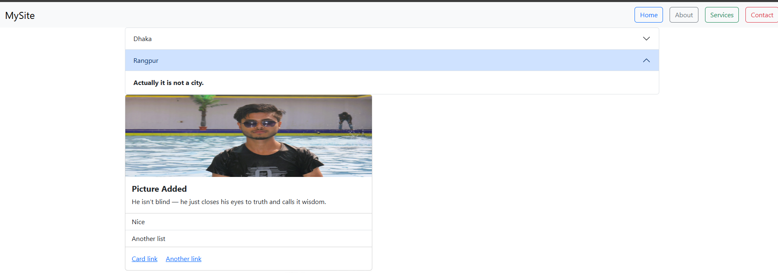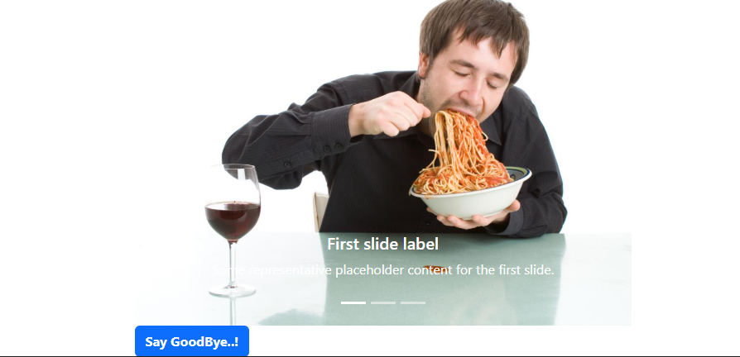

**LAB CLASS -7**

**Class topics:**

* Form design

HTML Code(index.html) :

<!DOCTYPE html>

<html lang="en">

<head>

  <meta charset="UTF-8" />

  <meta name="viewport" content="width=device-width, initial-scale=1.0" />

  <title>Custom Form</title>

  <link rel="stylesheet" href="css/index.css">

</head>

<body>

  <div class="container">  <form><div class="row"><div class="col"><label>Email address</label>

          <input type="email" placeholder="name@example.com" /></div>

        <div class="col"><label>Email address</label><input type="email" placeholder="

name@example.com" /></div>

       <div class="col"><label>Email address</label><input type="email"

placeholder="name@example.com" /></div>   </div>

      <div class="row">   <div class="col">

          <label>Email address</label>

          <input type="email" placeholder="name@example.com" /></div>   </div>

      <div class="row">     <div class="col">

          <label>Example textarea</label>

          <textarea rows="3"></textarea></div>    </div>

        <p><span class="deep-green">Lorem ipsum dolor sit amet consectetur,</span>

        adipisicing elit. Laborum, tempore fuga. Debitis nisi delectus deserunt sed sit doloribus facere commodi.  </p>

      <div class="row"><div class="col"> <div class="form-check"><input type="checkbox" id="checkDefault" />

            <label for="checkDefault">Default checkbox</label>

          </div>     </div>

        <div class="col">

          <div class="form-check">

            <input type="checkbox" id="checkChecked" checked />

            <label for="checkChecked">Checked checkbox</label>

          </div>    </div    </div>    </form>  </div>

</body>

</html>

CSS Code(index.css):

label {

      margin-bottom: 5px;

      font-weight: bold; }

    input[type="email"], textarea {

      padding: 8px;

      border: 1px solid #ccc;

      border-radius: 5px;

      font-size: 14px;

      width: 100%;}

    textarea {

      resize: vertical; }

    .deep-green {

      color: #198754;

      font-weight: bold;     }

    .form-check {

      display: flex;

      align-items: center;

      gap: 5px;

      margin-bottom: 10px; }

    .form-check input[type="checkbox"]{

      width: 18px;

      height: 18px;

    }

 body {

      font-family: Arial, sans-serif;

      background-color: #78f6b9;

      margin: 0;     padding: 20px;   }

    .container {

      max-width: 900px;

      margin: auto;

      background-color: #e0f7fa;

      padding: 20px;

      border-radius: 10px;

    }

    h1 {

      text-align: center;

      color: #0dcaf0; }

    form { margin-top: 20px; }

  .row {

      display: flex;

      gap: 20px; flex-wrap: wrap;

      margin-bottom: 15px;

    }

 .col {

      flex: 1;

      min-width: 150px;

      display: flex;

      flex-direction: column;

    }

Output: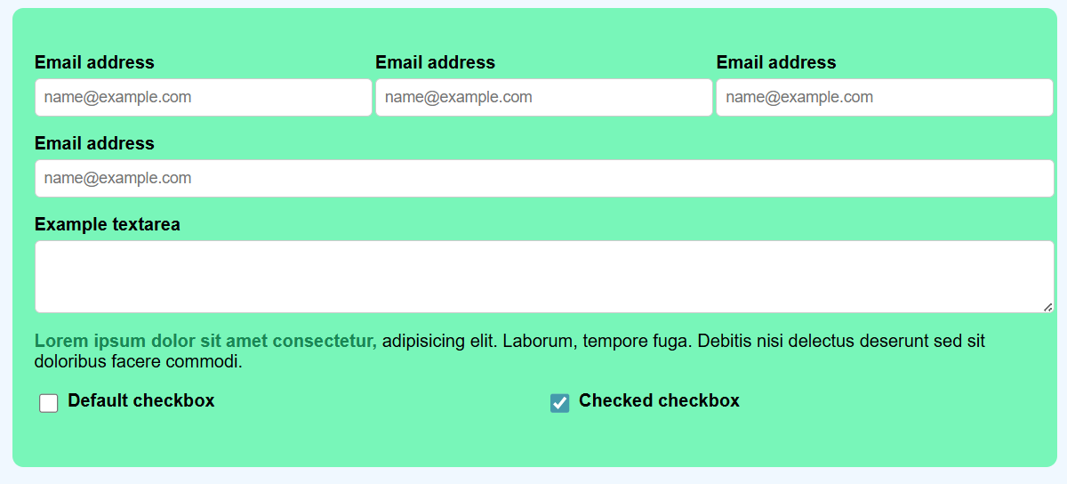

**LAB CLASS -8**

**Class topics:**

* First class of javascript
* Introduction of javascript

HTML Code(index.html):

<!DOCTYPE html>

<html lang="en">

<head>

    <meta charset="UTF-8">

    <meta name="viewport" content="width=device-width, initial-scale=1.0">

    <title>Document</title>

</head>

<body>

<script type="text/javascript" src="js/index.js"></script>

</body>

</html>

JS Code(index.js):

var x=130;

var y=80;

console.log(x+y);

document.write(x+y);

alert(x+y);

Output:

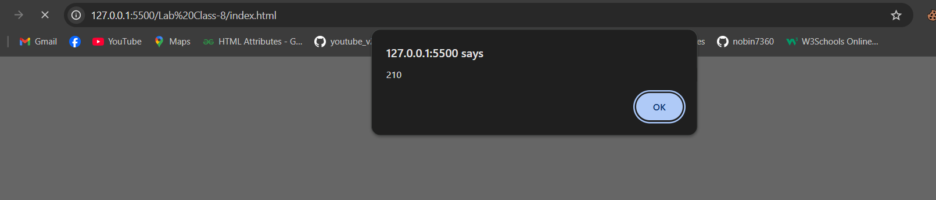

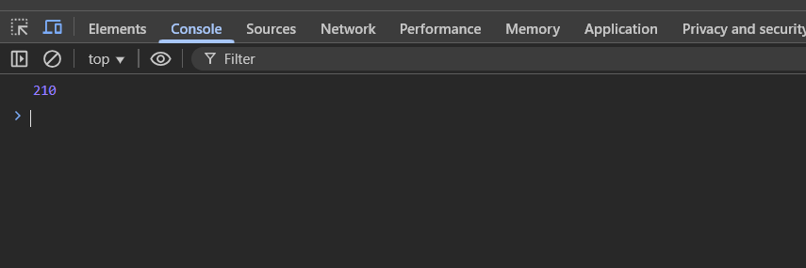

**LAB CLASS -9**

Class topics:

* Javascript variable
* Arithmetic methods
* Data types
* User input

HTML Code(index.html):

<!DOCTYPE html>

<html lang="en">

<head>

    <meta charset="UTF-8">

    <meta name="viewport" content="width=device-width, initial-scale=1.0">

    <title>Document</title>

</head>

<body>

<script type="text/javascript" src="js/index.js"></script>

</body>

</html>

JS Code(index.js)

var a = 30;

var a = 45; // Re-declaring with var is allowed

document.writeln("Value of a: " + a + "<br>");

let b = 250;

let c = "HelloWorld";

let v = 66.375;

document.writeln("Type of b: " + typeof(b) + "<br>");

document.writeln("Type of c: " + typeof(c) + "<br>");

document.writeln("Type of v: " + typeof(v) + "<br>");

let s = b.toString();

document.writeln("b as string: " + s + "<br>");

let x = "550.88";

let y = 80.4596;

x = parseFloat(x);

document.writeln("x as number: " + x + "<br>");

document.writeln("Type of x: " + typeof(x) + "<br>");

document.writeln("Invalid Number conversion: " + Number("XYZ") + "<br>");

document.writeln("Valid Number conversion: " + Number("567.89") + "<br>");

document.writeln("y toFixed(2): " + y.toFixed(2) + "<br>");

document.writeln("y toPrecision(4): " + y.toPrecision(4) + "<br>");

// let studFirstName = prompt("Enter your First Name");

// let studLastName = prompt("Enter your Last Name");

let studFirstName, studLastName;

studFirstName = prompt("Enter your First Name");

studLastName = prompt("Enter your Last Name");

document.writeln("<p style='color:blue;'>Hello, " + studFirstName + " " + studLastName + "!</p>");

Output:

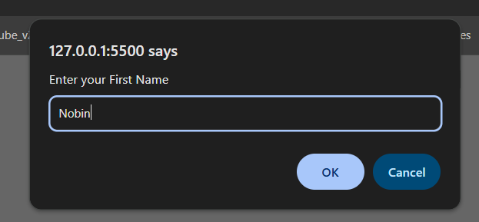 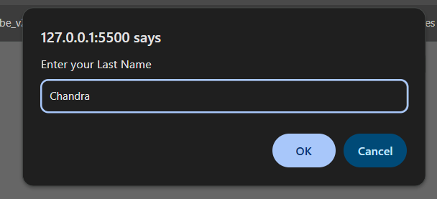

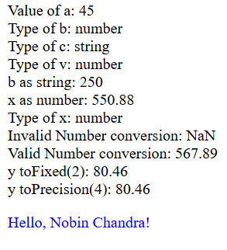

**LAB CLASS -11**

Class topics:

* Javascript Object
* DOM

HTML Code(index.html):

<!DOCTYPE html>

<html lang="en">

<head>

  <meta charset="UTF-8">

  <meta name="viewport" content="width=device-width, initial-scale=1.0">

  <title>Object & DOM Example</title>

</head>

<body>

  <h1 id="mainTitle">Student Information</h1>

  <h3>Department of Computer Science</h3>

  <p class="info">Welcome to the new session</p>

  <p class="header3">First Year Batch</p>

  <p class="header3">Second Year Batch</p>

  <ul> <li><a href="#">Contact</a></li>  </ul>

   <script type="text/javascript" src="js/index.js"></script>

</body>

</html>

JS Code(index.js):

    var name = "Nobin Chandra";

    var roll = 12345;

    var year = "2nd";

    var courses = ["Operating System", "Data Structure", "Algorithm"];

    var student1 = {

      name : "Nobin Chandra",

      roll : 12345,

      year : "2nd",

      courses : ["Operating System", "Data Structure", "Algorithm"]

    };

    document.writeln(student1.name + " " + student1.roll + " " + student1.year + " " + student1.courses + "<br>");

    function Student(name, roll, year, courses){

      this.name= name;

      this.roll = roll;

      this.year = year;

      this.courses = courses;

      this.display = function(){

        document.writeln(this.name + " " + this.roll + " " + this.year + " " + this.courses + "<br>");

      }

    }

    var student2 = new Student("Abdul", 123, "2025",

      ["Operating System", "Data Structure", "Algorithm"]);

    student2.display();

    document.writeln("Favorite Course: " + student1.courses[1] + "<br><br>");

    var header = document.getElementById("header1");

    document.writeln("getElementById: " + header.innerText + "<br>");

    header.innerHTML = "<p style='color:red;'>Hello</p>";

    var text1= document.getElementsByTagName("h3");

    document.writeln("From h3: " + text1[0].innerText + "<br>");

    document.writeln("From class header2: " + document.getElementsByClassName("header2")[0].innerText + "<br>");

    var text2 = document.querySelector('.header3');

    document.writeln("QuerySelector: " + text2.innerText + "<br>");

    var text3 = document.querySelectorAll('.header3')[1];

    document.writeln("QuerySelectorAll: " + text3.innerText + "<br>");

    document.querySelector("li a").innerHTML = "newContact";

Output:

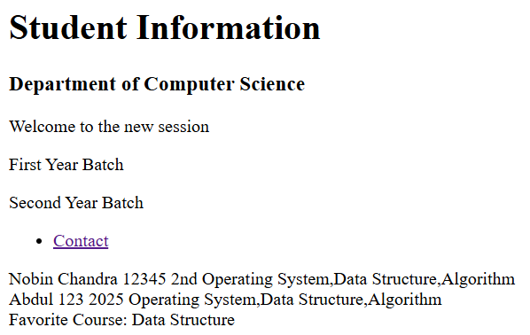

**LAB CLASS -12**

**Class topics:**

* More practice over DOM and added button to toggle a picture
* Toggle method usage

HTML Code(index.html):

<!DOCTYPE html>

<html lang="en">

<head>

  <meta charset="UTF-8">

  <meta name="viewport" content="width=device-width, initial-scale=1.0">

  <title>Toggle Image Example</title>

  <link rel="stylesheet" href="css/index.css">

</head><body>

  <div class="container">

    <button class="btn-info" onclick="buttonClick1()">Hello Button</button>

    <button class="btn-danger" onclick="paraClick()">Change Paragraph</button>

    <button class="btn-danger" onclick="toggleImage()">Toggle Image</button>

    <p id="paraId"> Lorem ipsum dolor sit amet consectetur adipisicing elit.

      Sint veniam dolore laborum ipsam itaque sequi autem mollitia aperiam facere.  </p>

    <img id="imageId" src="image/image6.jpg" alt="Image" height="300" width="300"></div>

  <script src="js/index.js"></script> </body>

</html>

CSS Code(index.css):

 body {

      font-family: Arial, sans-serif;

      margin: 30px;

      background: #f7f7f7; }

    .container {

      text-align: center;     }

    button {

      padding: 10px 20px;

      margin: 10px; border: none;

      border-radius: 5px; cursor: pointer;

      font-size: 16px; transition: 0.3s; }

    .btn-info {

      background-color: #17a2b8;

      color: white; }

    .btn-info:hover {

      background-color: #138496; }

 .btn-danger {

      background-color: #dc3545;

      color: white; }

    .btn-danger:hover {

      background-color: #b02a37; }

    #paraId {

      margin-top: 20px;

      padding: 15px;

      background: #d1ecf1;

      border-radius: 5px;

      font-size: 18px; }

    img {

      margin-top: 20px;

      border: 2px solid #ccc;

      border-radius: 10px;

    }

JS Code(index.js):

 function buttonClick1() { alert('Hello'); }

    function paraClick() {

      let text = document.getElementById('paraId');

      text.innerHTML = 'This is the second text of the paragraph.';

    } let toggle = true;

    function toggleImage() {

      let image = document.getElementById('imageId');

      if (toggle) { image.src = "image/image6.jpg"; } else {

        image.src = "image/image7.jpg"; }

      toggle = !toggle; // switch state }

**Output :**

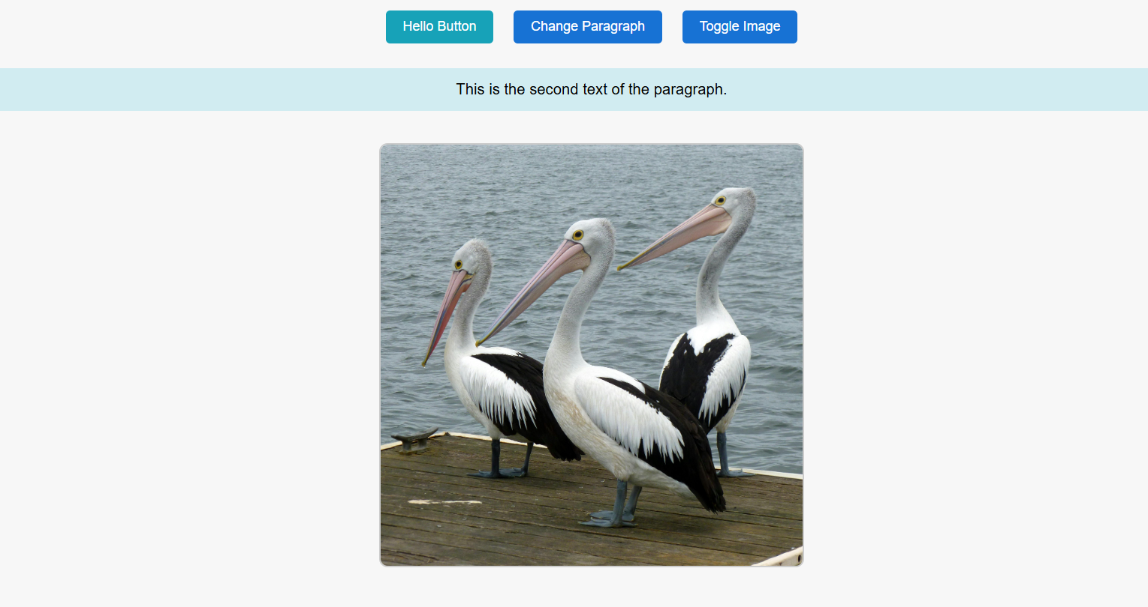

**LAB CLASS -13**

**Class topics:**

* Javascript function
* Arrow function
* Loop
* Condition( if,else,if else )
* More methods
* EventListener and more DOM practice

HTML Code(index.html):

<!DOCTYPE html>

<html lang="en">

<head>

  <meta charset="UTF-8">

  <meta name="viewport" content="width=device-width, initial-scale=1.0">

  <title>Improved JS Example</title>

  <link rel="stylesheet" href="css/index.css">

</head>

<body>

  <p id="paraId">This is a styled paragraph.</p>

  <button onclick="applyStyle()">Apply Style</button>

  <button onclick="removeStyle()">Remove Style</button>

  <button onclick="goNext()">Next Page</button>

  <button onclick="goBack()">Back Page</button>

  <button id="toggleBtn">Toggle Style</button>

  <br>

  <script src="js/index.js"></script>

</body>

</html>

CSS Code(index.css):

.para-style {

  color: blue;

  font-size: 2rem;

  font-weight: bold;

  font-style: italic;

}

JS Code(inedex.js):

let num = prompt("Enter a number:");

num = Number(num);

if (num > 10) { document.writeln(num + " is greater than 10<br>");

} else {

  document.writeln(num + " is less than or equal to 10<br>"); }

(num === 12)

  ? document.writeln(num + " is equal to 12<br>")

  : document.writeln(num + " is not equal to 12<br>");

function square(x) {

  return x * x; }

document.writeln("<br><span style='color:green;'>Square: " + square(num) + "</span><br>");

function applyStyle() {

  const para = document.querySelector("#paraId");

  para.classList.add("para-style"); }

function removeStyle() {

  const para = document.querySelector("#paraId");

  para.classList.remove("para-style"); }

function goNext() {

  location.href = "templates/next.html"; }

function goBack() {

  location.href = "../index.html"; }

const toggleBtn = document.querySelector("#toggleBtn");

toggleBtn.addEventListener("click", () => {

  document.querySelector("#paraId").classList.toggle("para-style"); });

const names = ["Nobin", "Bipin", "Durjoy"];

for (let n of names) {   document.writeln(n + ", "); }

let person = { id: 1, name: "Nobin" };

for (let key in person) { document.writeln("<br>" + key + " : " + person[key]); }

document.writeln("<br><br>ForEach Example:<br>");

let numbers = [30, 40, 50, 60];

numbers.forEach(n => document.writeln(n + "<br>"));

const greet = () => "Hello from Arrow Function!";

document.writeln("<br>" + greet());

const calculate = (a, b) => {

  document.writeln("<br>Sum: " + (a + b));

  document.writeln("<br>Difference: " + (a - b));

}; calculate(5, 3);

**Output :**

